**Linux test**

**Basic Linux Commands**

1. What command is used to list all files and directories, including hidden ones, in a directory?

ls -l ----> it used to viwe all the file and directories

ls -la ----> it used to viwe all the hidded files and directories

1. How do you display the contents of a file named `example` in the terminal?

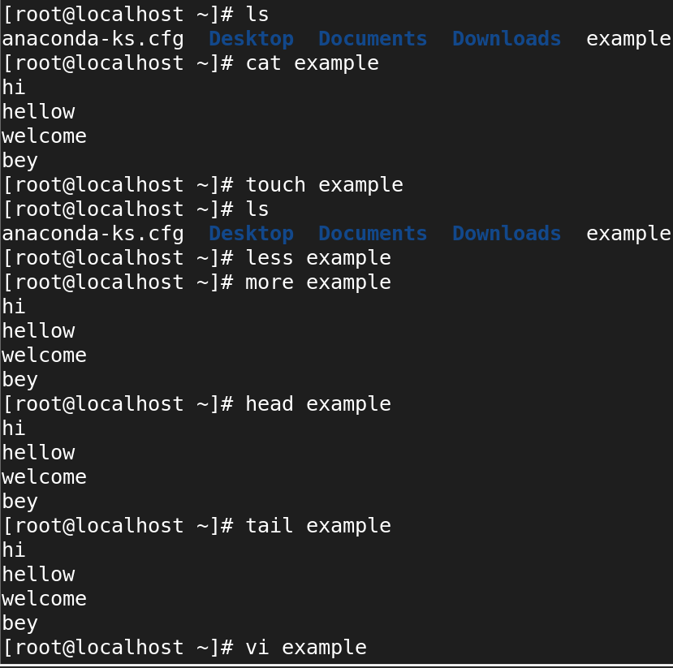

1. Which command is used to copy a file named `file1` to a directory `/backup`?

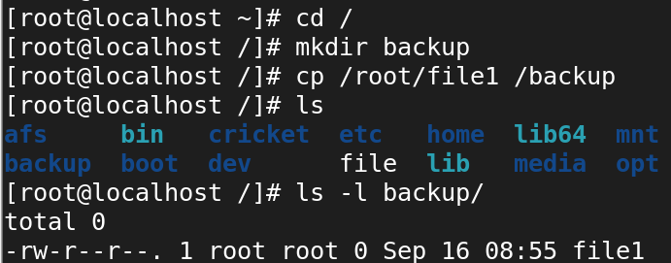

4. What is the command to move a file named `data` from the `/home/user` directory to

`/home/user/Documents`?

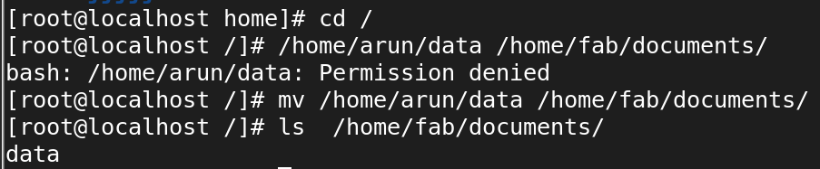

5.How would you create an empty file called `logfile`?

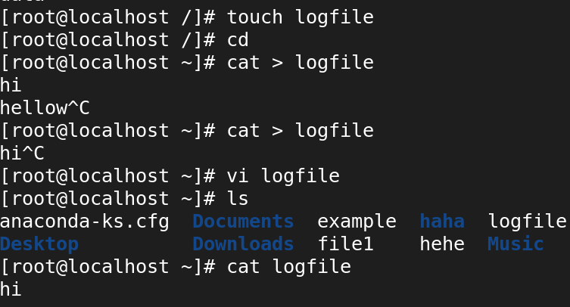

6.What command do you use to delete a directory named `old_files` and its contents?

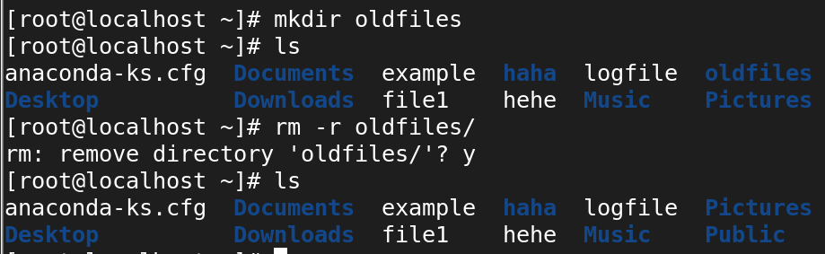

7.How do you check your current working directory in the terminal?

PWD ----> is used to check at the present working directory

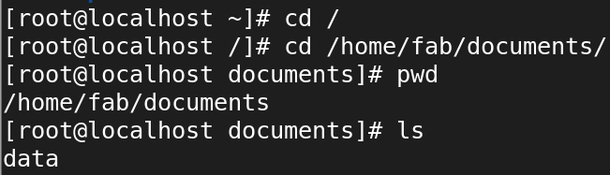

8.Which command is used to view the last 10 lines of a file called `system.log`?

**Tail --> command is used to viwe the last 10 line of file “system.log”**

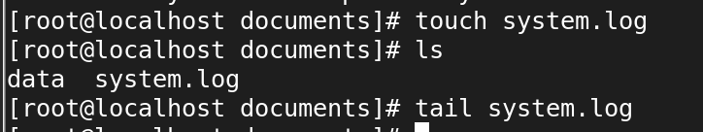

9. How would you change the current shell session to the root user, provided you have the proper permissions?

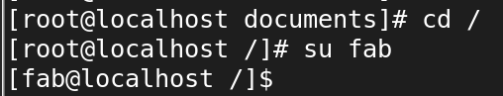

**Vi editor**

1. How do you open a file called `script` in the `vi` editor?

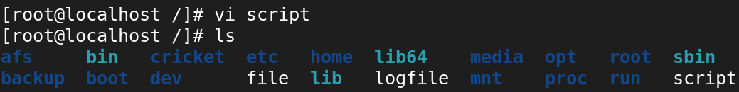

Once the file is open in vi, you can start editing the file after switching to **insert mode** by pressing **i.** To save and exit, press **Esc,** then type :**wq** and hit Enter.

1. In the `vi` editor, how do you enter insert mode to start editing a file?

In the vi editor, to enter **insert mode** and start editing a file, you can press one of the following keys:

* i: Inserts text at the current cursor position.
* a: Moves the cursor one character to the right and then enters insert mode.
* o: Opens a new line below the current line and enters insert

3.Which command do you use in `vi` to delete the current line?

dd: Deletes the entire line where the cursor is currently located.

4.How do you search for a word called `error` in `vi`?

 

/word --> to search any key word in file

?word

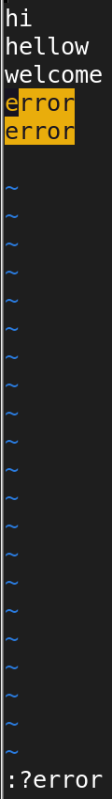

5.If you want to save the changes and quit the `vi` editor, what is the command for that?

:wq --> save and quite

:wq! --> forcefully save and quite (it will modify the time stamp )

:x --> save and quite

6.How do you undo the last action in `vi`?

* u 🡺 undo

7.In the `vi` editor, how do you move to the beginning of the file?

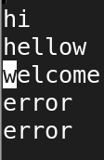

* I 🡺 insert from **beginning** of the line

8.What command can you use to copy and paste a line in `vi`?

* yy 🡺 copy
* 3yy 🡺 copy 3 lines from the courser
* P 🡺 paste
* 3p 🡺 paste 3 times

9.How do you quit `vi` without saving any changes?

* :q --> without saving quite from file
* :q! --> forcefully quite

10.Explain how to enter visual mode in `vi` to select text.

* v: Selects characters one by one.
* V: Selects entire lines.
* Ctrl + v: Selects a block of text, useful for columnar editing.

Once the text is selected, you can perform actions such as copying (y for yank), deleting (d), or pasting (p). To exit visual mode, press Esc.

**Basic File Permissions**

1. What command do you use to view the permissions of a file named `report`?



1. Explain what the following file permission means:

`-rwxr-xr--`.

7 ---> rwx 5 ---> rx 4 --->r

3. How would you change the permissions of a file called `test` to make it readable, writable, and executable by the owner, and readable and executable by the group and others?

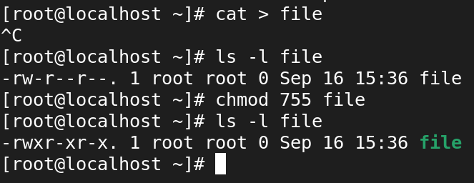

4.What is the command to change the ownership of a file named `data` to a user called `john`?

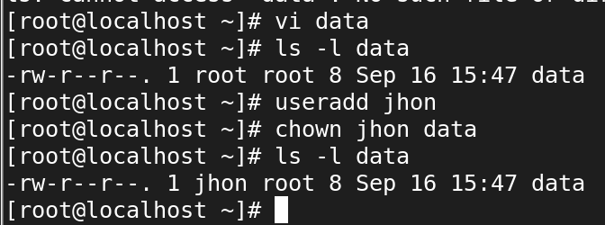

1. If you want to remove execute permissions for a group on a file named `script.py`, what command would you use?

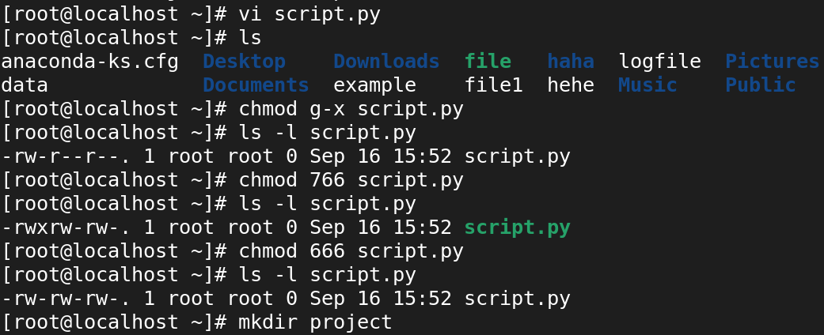

1. What does the `chmod 755 filename` command do to the file's permissions?

* It will change the permission of the file
* The user of the can acess full permission which means the user can read and write,execute.
* Then the group of file can read and execuete
* And others also according to the permission they can only read and execute.

1. How would you recursively change the permissions of all files and directories inside a directory called `project` to `755`?

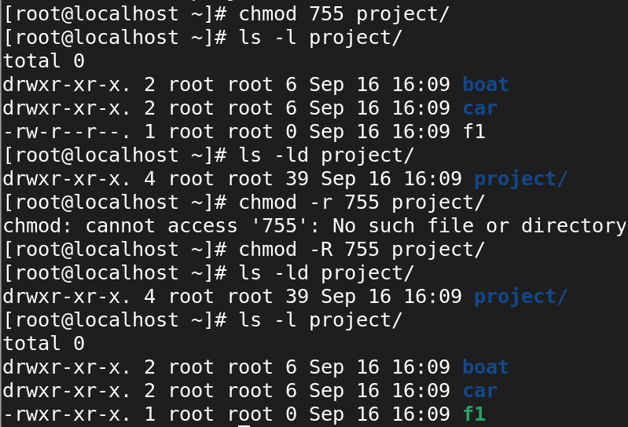

1. How do you check the default file permissions (umask) for newly created files and directories?

**Vi /etc/login.defs**

The above command is used see the defult umask --022 value.

1. What command can you use to set the owner of a file named `server.conf` to user `alice` and group `admins`?

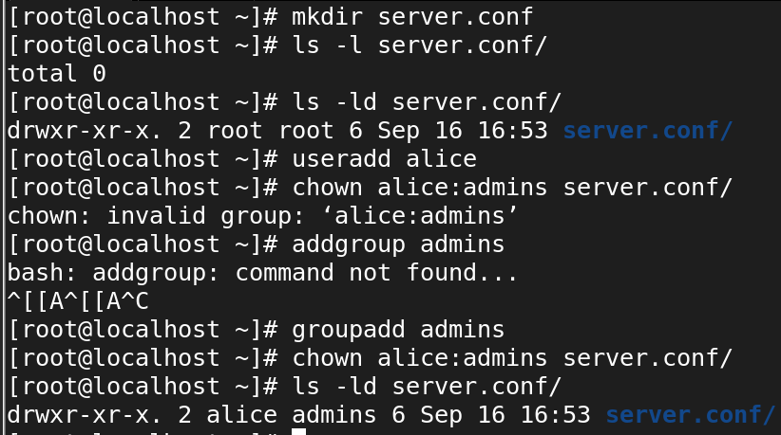

1. Describe how to make a file `read-only` for everyone using a symbolic mode command.

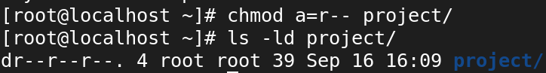

**User Management**

1. How do you add a new user called `student` in Linux?



1. What command would you use to delete a user named `testuser` along with their home directory?

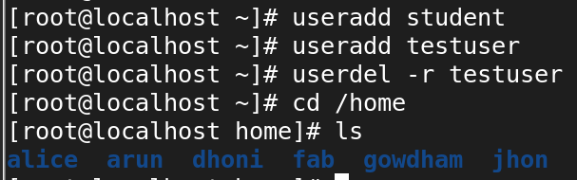

1. How can you lock the account of a user named `jane` to prevent them from logging in?

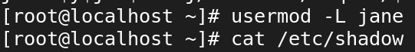



This command will prevent jane from logging in by placing an exclamation mark (!) in front of her encrypted password in the /etc/shadow file, effectively disabling her login credentials.

1. Which command would you use to change the password for a user named `bob`?

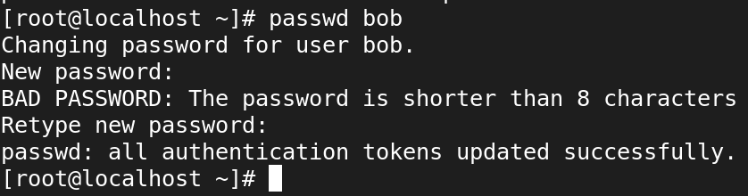

1. What is the command to view all users on a Linux system?

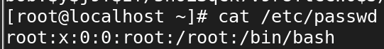

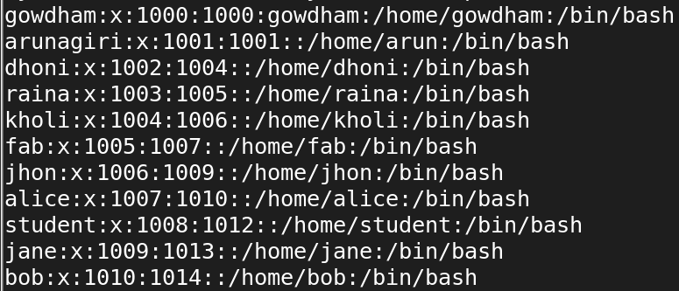

1. How do you list all the groups that a user called `developer` belongs to?

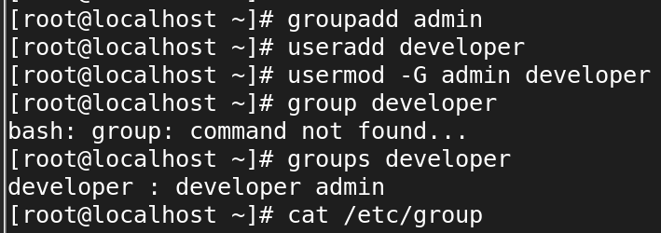



1. Explain how you would add an existing user `jack` to a group called `devgroupp`.

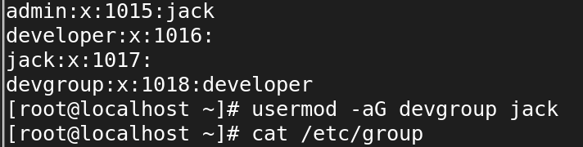

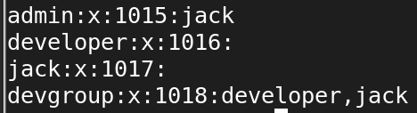

1. What command allows you to switch to another user’s account (without logging out of your current session)?

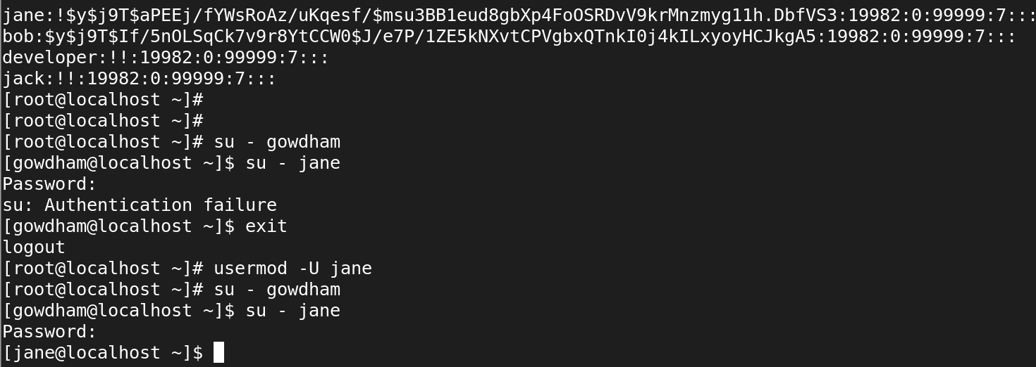

1. How do you add a group called `team` in Linux?

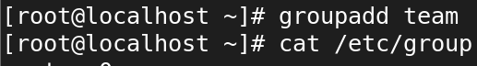

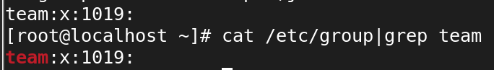

10. What is the purpose of the `/etc/passwd` file, and how is it structured?

The /etc/passwd file in Linux is a system file that stores user account information. It is essential for the system to identify users and manage their access. Each line in the /etc/passwd file represents a single user account and contains several fields separated by colons (:)

johndoe:x:1001:1001:John Doe:/home/johndoe:/bin/bash

* johndoe: Username
* x: Password placeholder
* 1001: UID
* 1001: GID
* John Doe: User info
* /home/johndoe: Home directory
* /bin/bash: Default shell

The /etc/passwd file is readable by all users, but writable only by the root user. This file provides essential information for user authentication and system management.